How to get two RTL-SDR dongles working dongles Windows

- Te first thing you should do is to install proper drivers for your RTL dongles. Usual way is to install Zadig drivers. This should be done for both RTL dongles. To check if every think is correct go to the device manager and see if the devices are correctly installed. To do that:
go to: settings → devices → on the bottom is devices manager, so go there and in devices for universal serial bus (on the list) you will find something like that:

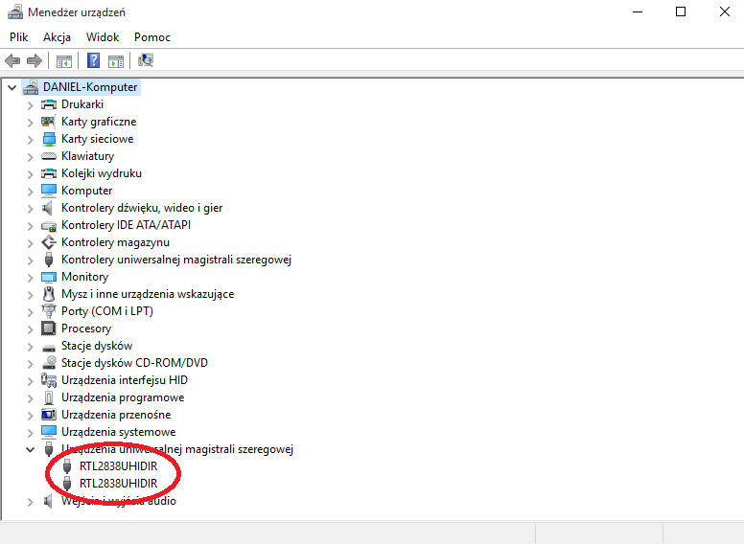

If the system configuration looks like above you are done!!! And skip the point 2.

2. It can be that one or more dongles are installed with standard drivers. In this situation it looks like that (It is under sound, video and games drivers).

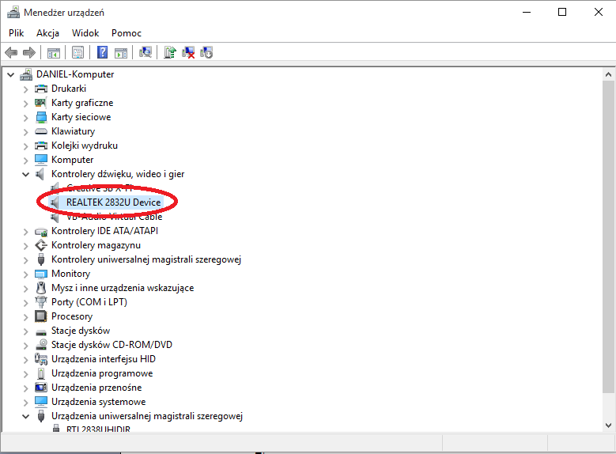
Don’t panic the simple solution is to replace the driver.
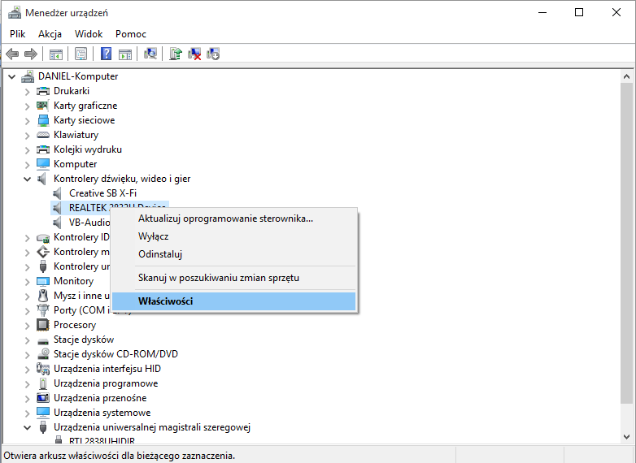
2.1. Go to device settings.

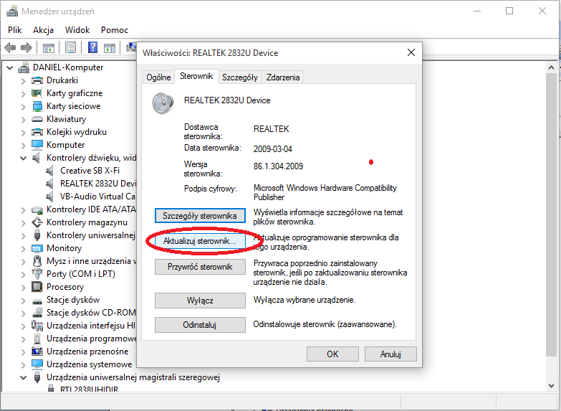
2.2 Go to update drivers.

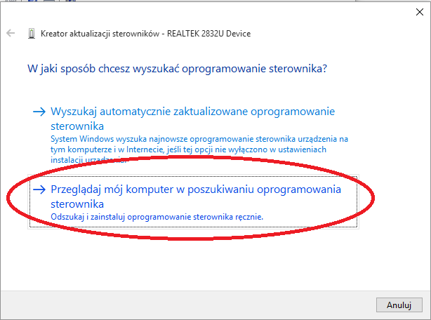
2.3. Go to second option update from my computer.

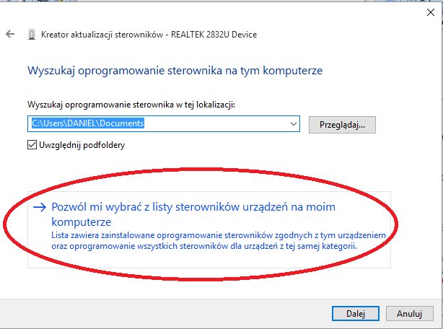
2.4. Go to option: let me chose from the driver list (I have polish version so it can by a bit different sentence) ☺

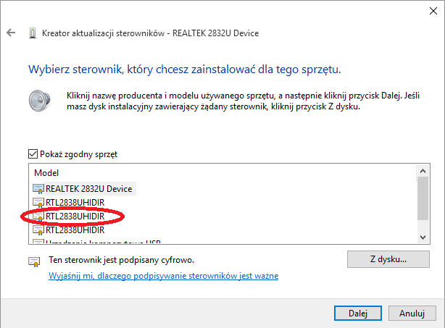
2.5. And select the proper driver. Probably computer will ask you to restart. You can do it but it is not necessary.

After that the manager should looks like in point 1.

